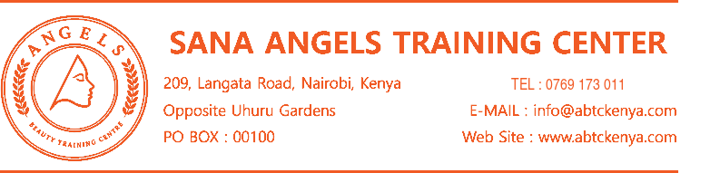
SCHOLARSHIP APPLICATION FORM
1. APPLICANT INFORMATION
Full Name |  | Date of Birth | YYYY. MM. DD.
Gender | ( ) Female ( ) Male ( ) Other | National ID No.
Phone Number |  | Email Address
Residential Address
Village |  | Sub-County
2. SCHOLARSHIP ELIGIBILITY
Please select ONLY ONE category that best describes your current situation.
( ) Single Mother | ( ) Woman with Multiple Children | ( ) Unemployed Woman
3. SINGLE MOTHER
Are you currently raising your child/children alone? | ( ) Yes ( ) No
Current Marital Status (Select one) | ( ) Never Married ( ) Divorced ( ) Other: ________
Number of Children
Required Supporting Documents
No. | Document Description | Check
1 | Copy of National ID | ( )
2 | Official Single Status Certificate issued by Village Chief | ( )
3 | Official Divorce Certificate issued by relevant authority (if applicable) | ( )
4 | Official Child Verification Certificate issued by Village Chief | ( )
5 | Income Proof - M-Pesa Statement | ( )
6 | Income Proof - Personal Bank Account Statement | ( )

4. WOMAN WITH MULTIPLE CHILDREN
Eligibility Criteria: 3 or more children under care
Number of Children
Children Information
No. | Child's Name | Age | Relationship
1
2
3
4
5
Required Supporting Documents
No. | Document Description | Check
1 | Copy of National ID | ( )
2 | Official Child Verification Certificate issued by Village Chief | ( )
3 | Income Proof - M-Pesa Statement | ( )
4 | Income Proof - Personal Bank Account Statement | ( )
5. UNEMPLOYED WOMAN
Are you currently employed? | ( ) Yes ( ) No
Date you stopped working | YYYY. MM. DD.
Length of Unemployment (Select one) | ( ) 1-2 years ( ) 2-3 years ( ) More than 3 years
Previous Occupation
Reason for Unemployment
Required Supporting Documents
No. | Document Description | Check
1 | Copy of National ID | ( )
2 | NHIF Statement - Previous 12 Months | ( )
3 | Income Proof - M-Pesa Statement | ( )
4 | Income Proof - Personal Bank Account Statement | ( )

6. INCOME & FINANCIAL INFORMATION
Current Source of Income  (Select all that apply) | ( ) No Income ( ) Casual Work ( ) Small Business  ( ) Self-Employment ( ) Other: ________________
Estimated Monthly Income
Other Financial Support (If any)
Briefly explain your financial situation:
7. TRAINING INFORMATION
Course Name | ( ) Skin Care ( ) Massage Therapy  ( ) Hairdressing ( ) Head Spa
Training Duration & Preferred Start Date | Training Duration: _____________________  Preferred Start Date: YYYY. MM. DD.
Why do you want to participate in this training?
Plan after completing training  (Select all that apply) | ( ) Employment ( ) Entrepreneurship  ( ) Further Training ( ) Other
Please explain your future plan:
8. APPLICANT DECLARATION
1. I declare that all information provided in this application is true and accurate.
2. I understand that the scholarship may be cancelled if any information or supporting document is found to be false or misleading.
3. I agree to attend the training regularly and comply with the rules and requirements of the training center.

Applicant Name  ______________________ | Date (YYYY. MM. DD.)  ______________________ | Signature  ______________________
FOR OFFICIAL USE ONLY
Application No. | Date Received | Reviewed By | Status
 | YYYY. MM. DD. |  | ( ) Approved  ( ) Not Approved

